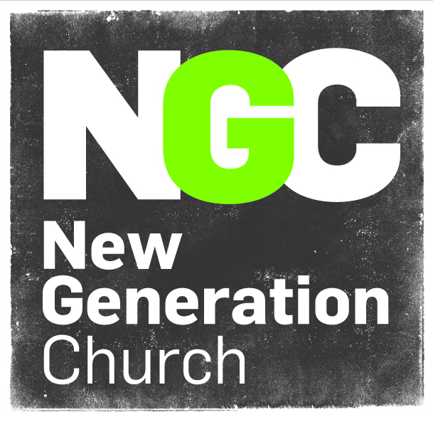

New Generation Church

Cyberbullying and E safety policy 2021

Updated March 2021
Review March 2022

All forms of bullying (including cyberbullying) should be handled as a community issue for the whole organisation. It is important that NGC takes measures to prevent and tackle bullying among children and young people that attend various activities. It is equally important to make it clear that bullying of staff, whether by children, young people, parents or colleagues, is unacceptable.

NGC leaders, youth and children’s workers, parents and children all have rights and responsibilities in relation to cyberbullying and should work together to create an environment free from harassment and bullying.

NGC can offer support to parents on how to help their children engage safely and responsibly with social media, perhaps through a parents’ evening, advice in a newsletter or signposting to other sources of support and advice.

It is not acceptable for young people, parents or colleagues to denigrate and bully staff via social media in the same way that it is unacceptable to do so face to face.

All staff are in a position of trust, and there are expectations that they will act in a professional manner at all times. Here is some key advice for staff which may help protect their online reputation:

- Enabling a PIN or pass code is an important step to protect you from losing personal data and images (or having them copied and shared) from your mobile phone or device if it is lost, stolen, or accessed by anyone.

- Be aware that your reputation could be harmed by what others share about you online, such as friends tagging you in inappropriate posts, photographs, or videos.
- Consider your own conduct online; certain behaviour could breach your employment code of conduct.
- Discuss these same issues with close family, friends and colleagues, as you could become a target if they do not have security and privacy settings in place.
- Do not accept friend requests from children or young people who attend or have attended activities arranged by NGC. If you feel this is necessary, you should first seek guidance from someone on the leadership team. Be aware that your social media friends may also be friends of parents or family members, of children or young people in your care and therefore could read your post if you do not have appropriate privacy settings.
- Do not give out personal contact details – if children or young people need to contact you with regard to activity arrangements, always use NGC ‘s contact details.
- Use NGC’s email address for business and personal email address for your private life; do not mix the two. This includes file sharing sites; for example Dropbox and YouTube.

If you are bullied online

- You should never respond or retaliate to cyberbullying incidents. You should report incidents appropriately and seek support from your team leader or the leadership team of NGC.
- Save evidence of the abuse; take screen prints of messages or web pages and record the time and date.
- Where the perpetrator is known to be a child or young person, the majority of cases can be dealt with most effectively through talking with the perpetrator and offering them help and advice.
- Where the perpetrator is known to be an adult, in nearly all cases, the first action should be for a leader to invite the person to a meeting to address their concerns, and if they have a reasonable complaint, to make sure they know how to raise this appropriately. They can request that the person removes the offending comments.
- If they refuse, it should be the leadership’s decision what to do next – either report the matter to the social networking site if it breaches their terms, or seek guidance from the local authority, legal advisers or support from other agencies for example, The UK Safer Internet Centre.
- If the comments are threatening or abusive, sexist, of a sexual nature or constitute a hate crime, you may consider contacting the local police. Online harassment is a crime.

Employers have a duty to support staff and no-one should feel victimised in the workplace.
The Professional Online Safety Helpline is a free service for professionals and volunteers working with children and young people, delivered by the UK Safer Internet Centre. The helpline provides signposting, advice and mediation to resolve the e-safety issues which staff face, such as protecting professional identity, online harassment, or problems affecting young people; for example cyberbullying or sexting issues.

The Safer Internet Centre has developed strategic partnerships with the key players in the internet industry. When appropriate, this enables the Professional helpline to seek resolution directly with the policy and safety teams at Facebook, Twitter, YouTube, Google, Tumblr, Ask.FM, Rate My Teacher and more.
All employers, have statutory and common law duties to look after the physical and mental health of their employees. This includes seeking to protect staff from cyberbullying by young people, parents and other members of staff and supporting them if it happens.

